Catalyst Driving Business Excellence

Kitchener, Ontario

Project Rogers

Assignment 1

|  |  |
| --- | --- |
| Group # | CP 5 |
| Student Name | Rakesh Mahendranath [8826237], Govind Kala Raveendran, Charumathi Satish, Aiswarya Raj [8870519], Het Chandubhai Patel [8878174], Vignesh Ramasubramanian [8857425] |
| Course | INFO8686 – Information Technology Business Analysis Capstone Project |
| Section | 5 |
| Professor | Prof. Nilesh Deshmukh |
| Due Date | Jan 18, 2024 |

Table of Contents

Company Overview 3

Financial Status 3

Wireless 3

Cable 4

Media 5

Revenue Analysis 6

Market Share 6

Executive Team 7

Organizational Structure 11

Mission Statement 11

Vision Statement 11

Competitive Analysis 13

SWOT Analysis 13

PESTEL Analysis 14

Balanced Scorecard 18

RACI Matrix 19

References 20

# Company Overview

**Rogers Communications** **Inc.**, headquartered in Toronto, Ontario, is a Canadian company specializing in wireless communications, cable television, telephony, and internet services, with substantial telecommunications and mass media holdings.

The Rogers portfolio of businesses include three major contributing divisions which are:

* **Rogers Wireless:** Providing wireless communication services, including mobile voice, data, and messaging.
* **Rogers Cable**: Offering cable television, high-speed internet, and home phone services.
* **Rogers Sports & Media:** Focused on sports content, including ownership of sports teams, and other media ventures.

Other divisions include:

* **Rogers Communications**: Encompassing television, radio, digital media, and publishing assets to provide entertainment and information services.
* **Rogers Smart Home Monitoring:** Providing a comprehensive range of services for both residential and business customers, including connected home solutions.
* **Rogers for Business:** Catering to the needs of businesses with a range of communication and technology solutions.
* **Rogers Bank**: Managing financial products and services, including Rogers Bank.

## Financial Status

### Wireless

Rogers is a Canadian industry leader in providing cutting-edge wireless network technologies and services. The firm was the first Canadian carrier to build a 5G network, and it currently has the largest 5G network in Canada, servicing over 1,900 locations as of December 31, 2022. Rogers, Fido, and Chatr brands offer postpaid and prepaid wireless services to consumers and companies, offering them with the most recent wireless devices, services, and applications.

As of December 31, 2022, Rogers has approx.:

* 10.6 million wireless mobile phone subscribers
* 30% subscriber and revenue share of the Canadian wireless market

### Cable

Rogers is one of the largest cable providers in Canada. The company's cable network offers an innovative and leading selection of high-speed broadband Internet access, Internet protocol-based (IP) television, applications, online viewing, phone, smart home monitoring, and advanced home Wi-Fi services to consumers in Ontario, New Brunswick, Nova Scotia, and on the island of Newfoundland.

As of December 31, 2022, Rogers had approx.:   
• 2.3 million retail Internet subscribers.

• 1.5 million Video subscribers; and

• a network passing of 4.8 million homes

### Media

Roger MEDIA's array of media assets, which includes sports and regional TV and radio content, reaches Canadians from coast to coast. In Sports Media and Entertainment, the corporation owns the Toronto Blue Jays, Canada's sole Major League Baseball (MLB) franchise, as well as the Rogers Centre, which holds home games, concerts, trade fairs, and special events. MEDIA's partnership with the NHL (NHL partnership, enables the firm to deliver over 1,300 regular season games per season via television, smartphones, tablets, personal computers, and other streaming devices. It also grants MEDIA national rights on those channels to the Stanley Cup Playoffs and Stanley Cup Final, as well as other NHL-related special and non-game events.

## Revenue Analysis

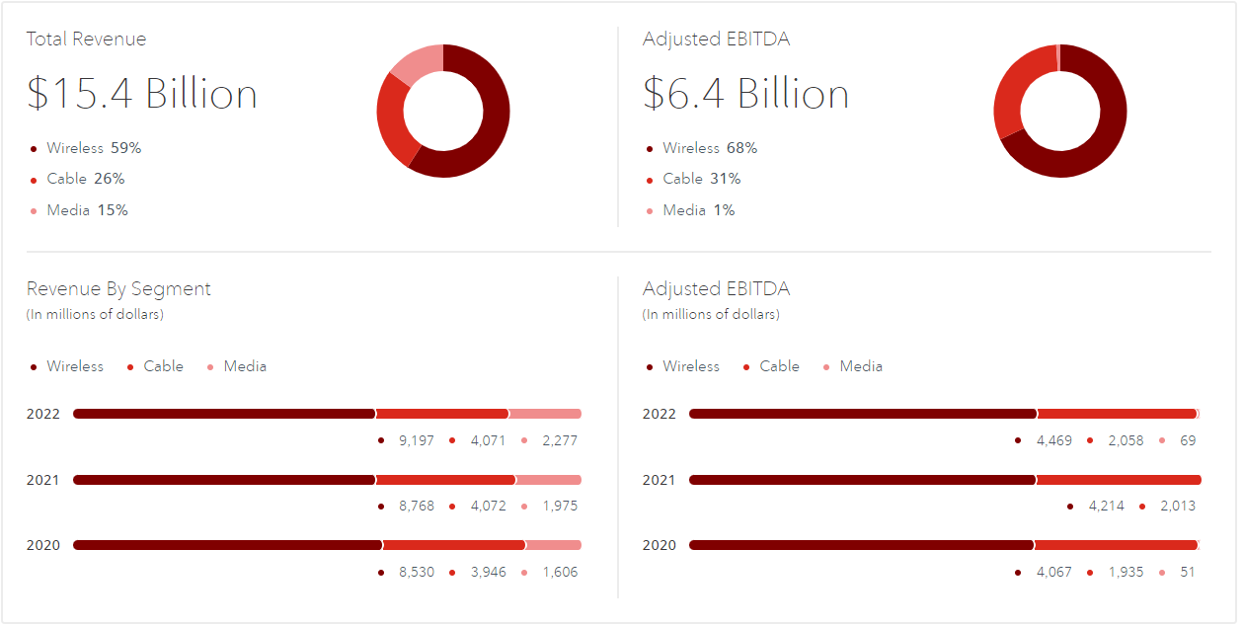

## Market Share

Rogers, Bell and Telus account for 82% of wireless revenue when combined compared to other operators in the mobile network segment. The total wireless subscribers in Canada amounts to over 33 million. Around 87.8% of mobile phone users are serviced by the three major telecommunication companies. These firms own and control transmission systems that serve a large percentage of the country, occasionally sharing networks in specific areas to save money and expand their client base.

The remaining 10% of subscribers are spread across smaller regional carriers, mobile virtual network operators (MVNOs), and resellers. Regional providers operate in specific areas and collaborate with national service providers to connect their consumers nationwide.

In 2022, Bell Canada (BCE) had the greatest share of commercial television revenues in Canada, accounting for 32.7 percent. Rogers held 16.6 percent of the market, trailing Corus/Shaw, which controlled 17 percent of overall commercial TV revenues in the country.

## Executive Team

|  |  |  |
| --- | --- | --- |
| **Name** | **Position** | **Description** |
| **Tony Staffieri** | President and CEO | Tony Staffieri, President, and CEO of Rogers Communications, is a seasoned leader with a nine-year tenure as Chief Financial Officer, driving strong results and shareholder value. His diverse leadership background includes roles at Price Waterhouse Coopers, Celestica International, and Bell Canada Enterprises. Beyond his corporate role, Tony is actively involved as Chair of the Toronto Metropolitan University Board of Governors and a Board Director at Maple Leaf Sports & Entertainment (MLSE). |
| **Phil Hartling** | President, Wireless | Phil Hartling, as President, of Wireless at Rogers, oversees the company's Wireless business encompassing the Rogers, Fido, and Chatr brands. With over 30 years of telecom experience, Phil has held various leadership roles, demonstrating a strong track record of profitable growth, operational discipline, and team building. Notably, he led the service area expansion program and previously headed the Connected Home business at Rogers. |
| **Colette Watson** | President, Rogers Sports & Media | As the President of Rogers Sports & Media since January 2022, Colette Watson leads a $2 billion business with around 3,000 employees, overseeing diverse sports and media properties, including TV channels, radio stations, OTT services, podcast networks, and more. With 30 years of experience in Canada's broadcast industry, Colette has held senior roles in programming, regulatory affairs, and communications at Rogers Media. Beyond her corporate responsibilities, she is passionate about public affairs and journalism, having served as the President of CPAC. |
| **Robert Depatie** | President & COO, Home & Business Division at Rogers Communications | Robert Depatie, President and COO of Rogers' Home and Business Division, brings nearly 20 years of telecom and media leadership. Formerly CEO of Quebecor and President of Videotron, he emphasizes customer-first strategies, driving notable improvements in satisfaction and business growth. Committed to the community, he engages in fundraising and initiatives for rehabilitation and community development. |
| **Ron McKenzie** | Chief Technology and Information Officer | As Chief Technology & Information Officer at Rogers Communications since July 2022, Ron McKenzie leads a team overseeing wireline, wireless, and media networks, along with IT and digital strategy. With over 30 years in the technology and telecom industry, he previously served as President, of Rogers for Business, focusing on delivering solutions to businesses. Ron's leadership includes successful transformations in Technical Operations during the COVID-19 pandemic, ensuring customer connectivity and team safety. |
| **Glenn Brandt** | Chief Financial Officer | As the Chief Financial Officer of Rogers Communications since January 2022, Glenn Brandt brings over 35 years of financial management expertise, specializing in corporate finance, capital raising, and credit rating agencies. With a 31-year tenure at Rogers, he previously served as Senior Vice President of Corporate Finance, overseeing Procurement, Supply Chain, Tax, Treasury, and pension investing. Glenn's extensive background includes leadership in the Treasury, contributing to approximately $50 billion in public debt issues for Rogers in Canada and the United States. |
| **Mahes Wickramasinghe** | Chief Commercial Officer | As Chief Commercial Officer at Rogers since January 2022, Mahes Wickramasinghe oversees key initiatives and operations, including Strategy, Corporate Development, and Financial Services, including Rogers Bank. With over two decades of senior executive experience, he previously led Canadian Tire Financial Services and held roles at Canadian Tire Corporation, CIBC Retail Bank, Bell Aliant, BCE Inc., and Rogers Communications. Mahes, a Chartered Accountant, is actively involved in various boards, including SunOpta Inc. and The Association of International Certified Professional Accountants. |
| **Marisa Wyse** | Chief Legal Officer and Corporate Secretary | As Chief Legal Officer and Corporate Secretary at Rogers, Marisa Wyse is a strategic leader with expertise in legal and regulatory affairs. Joining Rogers in 2014, she has played key roles in Tax and Finance and served as Vice President of Corporate Development, overseeing mergers and acquisitions. |
| **Bret Leech** | Chief Human Resources Officer | Bret Leech, the Chief Human Resources Officer at Rogers since February 2022, leads the company's HR portfolio, focusing on creating an engaging and inclusive employee experience. With 25 years of international leadership experience in telecommunications, finance, and technology, Bret has a strong track record in building high-performing teams. |
| **Terrie Tweddle** | Chief Brand and Communications Officer | As the Chief Brand and Communications Officer since April 2023, Terrie Tweddle leads communications and brand efforts at Rogers, focusing on enhancing the company's reputation. With 25 years of experience, she has a passion for building culture, managing complex issues, and creating award-winning campaigns. Notably, she returned to Rogers in 2022 after a 12-year tenure at the company, showcasing her commitment to its continued success. |
| **Navdeep Bains** | Chief Corporate Affairs Officer | As Chief Corporate Affairs Officer at Rogers since May 15, 2023, The Honourable Navdeep Bains leads Public Policy and Environmental, Social, and Governance (ESG) efforts, leveraging his expertise to address critical issues in Canada's digital economy. Formerly Vice-Chair in Global Investment Banking for CIBC, he played a key role in strengthening Capital Markets and Commercial Banking with a focus on Innovation and Sustainability. With a distinguished background, Navdeep served as one of the longest-serving federal Ministers of Innovation, Science, and Industry, introducing a comprehensive innovation and skills plan for Canada. |
| **Zoran Stakic** | President, Residential | As President of residential at Rogers since September 2023, Zoran Stakic oversees strategy and operations, bringing 25 years of deep telecom sector experience. Formerly Chief Transformation Officer, he led the integration process of Shaw and Rogers, ensuring a seamless transition. Zoran's extensive executive leadership background includes roles at Shaw, where he served as Chief Operations Officer and Chief Technology Officer. |

*(2023 Annual Report | Rogers, 2023)*

## Organizational Structure

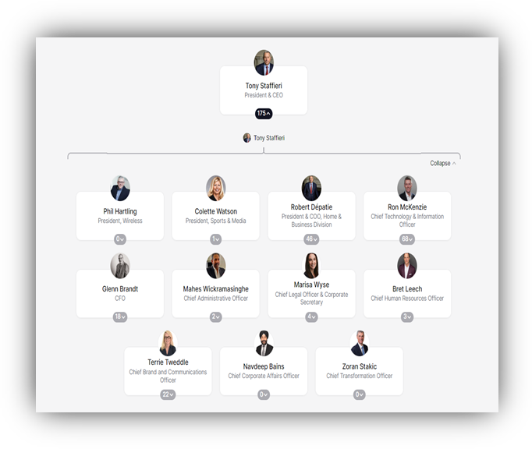

(Rogers, 2023)

## Mission Statement

"At Rogers, our mission is to connect Canadians by being a responsible business for customers and shareholders, a supportive employer, and a good neighbor. We prioritize continuous learning and respond to changing societal expectations, focusing on corporate social responsibility. We tackle emerging challenges, with a special emphasis on reducing our environmental impact. We're dedicated to helping customers adopt sustainable practices while delivering innovative, accessible products, and services." (Rogers, 2023)

## Vision Statement

"Our vision is to lead in corporate social responsibility, setting new standards for excellence and innovation. We adopt a rigorous approach aligned with stakeholder expectations, addressing emerging issues to strengthen our commitment to responsible business conduct. We aim to contribute to positive change, foster a sustainable and connected future, and leave a legacy of responsible corporate citizenship. Our focus is on adding significant value to customers' lives through cutting-edge and accessible products and services." (Rogers, 2023)

# Competitive Analysis

## SWOT Analysis

|  |  |  |  |  |
| --- | --- | --- | --- | --- |
|  |  |  |  |  |
| **PURPOSE** | | | | |
| To find out performance of Rogers Communications against its competitors: Bell Canada, Telus Corporation and Verizon | | | | |
|  |  |  |  |  |
| **S** | INTERNAL **STRENGTHS** |  | **W** | INTERNAL **WEAKNESSSES** |
| **1** | Rogers turned its junk bond status to investment grade, indicating strong balance sheet and financial stability (Rogers Communications Inc., 2022) |  | **1** | No presence in US when compared to Verizon (Rogers Communications Inc., 2020). |
| **2** | All call centers are located in Canada, enhancing customer satisfaction (Rogers Communications Inc., 2022) |  | **2** | Less fiber optic network when compared to Telus (Telus Corporation, 2021). |
| **3** | Owns media properties and sports rights such as NHL |  | **3** | Media unit profitability lags behind rivals (Rogers Communications Inc., 2021) |
| **4** | Has a strong brand image and customer loyalty (Rogers Communications Inc., 2022) |  |  |  |
|  |  |  |  |  |
| **O** | EXTERNAL **OPPORTUNITIES** | **[42]** | **T** | EXTERNAL **THREATS** |
| **1** | Leverage media properties by forming partnerships (TMX Money, 2021) |  | **1** | Bell and Telus are offering cheaper plans than Rogers in the cellular market thereby becoming more competitive (CRTC, 2020) |
| **2** | Grow market share in Western Canada vs Telus and Bell (Roussel, 2021) |  | **2** | Expenses for investments in advanced networks is increasing (Rogers Communications Inc., 2021) |
| **3** | Acquisition of Shaw Communications Inc. may increase customers and market share (Rogers Communications Inc., 2022). |  | **3** | Changes in government regulations could affect operations and thereby financial performance (Rogers Communications Inc., 2022). |
| **4** | Promoting the Connected for Success program can increase market share by bringing in customers with low income (Rogers Communications Inc., 2022). |  | **4** | Consumer spending is being affected by economic weakness in Canada (Statistics Canada, 2022) |
|  |  |  |  |  |
|  |  |  |  |  |
| **ACTION ITEMS & GOALS** | | | | |
| **1** | Promote customer service and Canadian-based call centers to differentiate Rogers from the competitors | | | |
| **2** | Explore options to enter US market | | | |
| **3** | Leverage Shaw acquisition to expand customer base | | | |
| **4** | Focus on marketing to promote the Connected to Success program to bring in new customers from low-income households. | | | |
| **5** | Collaborate with government around public and environmental policies | | | |
|  |  |  |  |  |

## PESTEL Analysis

|  |  |  |  |  |
| --- | --- | --- | --- | --- |
|  | **Rogers** | **Telus** | **Bell Canada** | **Verizon** |
| **Political** | Adherence to Canadian regulatory framework, CRTC regulations, and government policies. | Regulatory compliance with the Canadian Radio-television and Telecommunications Commission (CRTC) | Adherence to regulations set by the CRTC, impacting pricing, net neutrality, and spectrum allocation. | FCC regulations influence the U.S. telecommunications market's pricing, services, and quality. |
|  | Consideration of overall political stability in Canada. | Impact of government stability and policies on business operations. | Influence of trade policies and international relations on partnerships and supply chain. | Taxation laws and policies affect operating costs. |
|  | Monitoring changes in Canadian government policies and their impact on operations. | Exposure to different political climates across Canadian provinces and territories. | Consideration of overall political stability in Canada. | Consideration of overall political stability in the U.S. |
| **Economic** | Economic conditions influence consumer spending on telecommunications services. | Global economic conditions that affect consumer spending on telecommunications services. | Fluctuations in interest rates that impact borrowing costs. | Impact of exchange rates on international revenue. |
|  | Monitoring changes in economic conditions affecting market dynamics. | Influence of exchange rates on financial performance. | Economic growth influencing consumer spending on telecom services. | Influence of interest rates on borrowing costs, infrastructure investment, and spending. |
|  | Adaptation to market conditions and customer spending patterns. | Consideration of interest rates and their impact on borrowing and investment. | Regulatory changes, such as tax policies and trade agreements, affect cost structure. | Consideration of inflation and its impact on costs and profitability. |
|  | Response to changes in market conditions and consumer behavior. | The overall impact of global economic conditions on revenue and profitability. | Market conditions, inflation rates, and unemployment levels influence consumer behavior. | Consideration of unemployment rates affecting consumer spending on devices and services. |
| **Social** | Catering to diverse demographics, changing communication needs, and adapting to cultural trends. | Adaptation to changing demographics, increasing reliance on mobile technology, and environmental sustainability. | Response to changing lifestyles and preferences, increasing reliance on mobile technology, and environmental sustainability. | Catering to the communication needs of an aging population and targeting Millennials and Gen Z. |
|  | Understanding and adapting to social trends and diverse customer preferences. | Investments in high-speed internet and flexible plans to meet changing needs. | Consideration of cultural trends, population demographics, and attitudes towards work and leisure. | Integration with social media platforms and adaptation to technological trends in communication. |
|  | Response to environmental sustainability concerns and diverse societal expectations. | Proactive measures for environmental sustainability and resonance with environmentally conscious consumers. | Adaptation to attitudes towards work and leisure, lifestyle changes, and cultural trends. | Consideration of cultural differences in global operations. |
| **Technological** | Emphasis on technological advancements, network reliability, and digital services innovation. | Focus on advanced technologies, 5G network deployment, IoT solutions, and digital healthcare services. | Investment in technological infrastructure, partnerships for IoT solutions, and digital transformation initiatives. | Investment in advanced technology, 5G technology launch, and dependence on continuous innovation. |
|  | Ongoing investments in advanced technology and network infrastructure. | Leadership in technological advancements in the telecommunications industry. | Technological factors influencing infrastructure, services, and customer experience. | Key strengths include solid and reliable wireless networks, investing in 5G technology, and continuous innovation. |
|  | Focus on digital transformation and technology-led customer experience enhancement. | Environmental considerations in technology usage and investments. |  |  |
| **Environmental** | Initiatives for reducing environmental impact, energy efficiency, and sustainable practices. | Impact of climate change on network infrastructure, environmental regulations compliance, and natural resource availability. | Consideration of climate change, environmental regulations compliance, and natural resource availability. | Commitment to reducing carbon footprint, eco-friendly product launches, regulatory compliance, and waste management. |
|  | Focus on responsible waste management and eco-friendly product offerings. | Proactive measures include investing in renewable energy sources, reducing energy consumption, and participating in environmental initiatives. |  | Preparedness for natural disasters and implementation of emergency response plans. |
|  | Adherence to environmental regulations and continuous improvement in sustainability practices. | Launch of eco-friendly products in response to increasing demand for sustainability. |  |  |
| **Legal** | Compliance with Canadian legal requirements, data protection laws, and industry regulations. | Compliance with various laws and regulations governing telecommunications, privacy, data protection, and competition. | Impact of regulatory compliance, legal disputes, government policies, and international laws on operations. (Team, 2023) | Adherence to federal, state, and local regulations, data protection laws, Net Neutrality, and protection of intellectual property rights. |
|  | Focus on privacy laws, consumer protection, and legal compliance. (Team, 2023) | Data protection laws and regulations. (Team, 2023) |  | Net Neutrality regulations and protection of intellectual property rights. (Team, 2023) |

## Balanced Scorecard

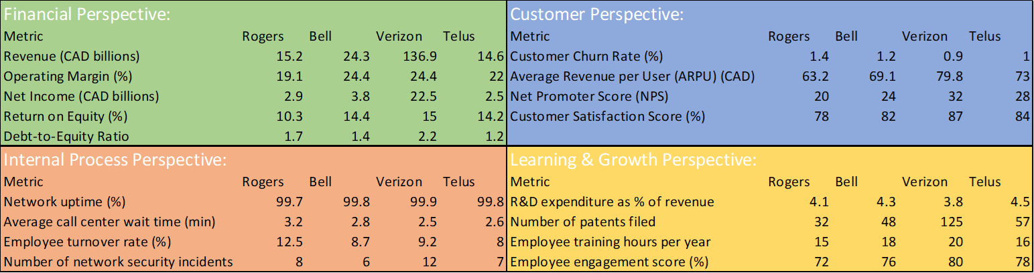

# RACI Matrix

# References

1. Rogers Communications Inc. (2022). 2022 Annual Report Retrieved from <https://investors.rogers.com/2022-annual-report>
2. Telus Corporation. (2021). 2021 Annual Report Retrieved from <https://www.telus.com/en/about/investor-relations/reports/annual-reports/2021>
3. Rogers Communications Inc. (2021). 2021 Annual Report Retrieved from <https://investors.rogers.com/2021-annual-report>
4. TMX Money. (2021, March 1). Rogers and FuboTV announce strategic partnership bringing sports and entertainment content to FuboTV subscribers in Canada [Press release]. <https://money.tmx.com/en/quote/RCI.b/news/5884465543277506/rogers-and-fubotv-announce-strategic-partnership-bringing-sports-and-entertainment>
5. Roussel, A. (2021). *Telus, Bell and Rogers have lost 2.6% of cell phone market share over 5 years in Canada*. Hellosafe. Retrieved January 17, 2024, from <https://hellosafe.ca/en/blog/cellphone-carriers-market>
6. Canadian Radio-television and Telecommunications Commission (CRTC). (2020). Communications monitoring report. <https://crtc.gc.ca/eng/publications/reports/policyMonitoring/2020>
7. Team, D. (2023, December 6). *PESTEL Analysis of Rogers Communications Inc. (RCI)*. Dcf-fm. <https://dcf.fm/blogs/blog/rci-pestel-analysis>
8. Team, D. (2023, December 6). *PESTEL Analysis of TELUS Corporation (TU)*. Dcf-fm. <https://dcf.fm/blogs/blog/tu-pestel-analysis>
9. Team, D. (2023, December 6). *PESTEL Analysis of BCE Inc. (BCE)*. Dcf-fm. <https://dcf.fm/blogs/blog/bce-pestel-analysis>
10. Team, D. (2023, November 28). *PESTEL Analysis of Verizon Communications Inc. (VZ).* Dcf-fm. <https://dcf.fm/blogs/blog/vz-pestel-analysis>
11. Verizon. (2023). Investor.<https://www.verizon.com/about/investors>
12. BCE. (2023). Investor.<https://www.bce.ca/investors/overview>
13. Statistics Canada. (2023). <https://www.statcan.gc.ca/en/start>
14. Government of Canada. (2023). Patent. <https://www.ic.gc.ca/opic-cipo/cpd/eng/search/basic.html>
15. Government of Canada. (2023). Canadian Radio-television and Telecommunications Commission <https://crtc.gc.ca/eng/publications3.htm>
16. Opensignal. (2023). <https://www.opensignal.com/>
17. GWI. (2023).<https://www.gwi.com/reports/social>
18. Government of Canada, C. R. and T. C. (CRTC). (2023, December 1). Communications market reports. CRTC. <https://crtc.gc.ca/eng/publications/reports/policymonitoring/cmrd.htm>
19. J.D. Power. (2023). Canadian Wireless Customer Satisfaction Study. <https://www.jdpower.com/business/press-releases/2023-us-wireless-customer-care-study-volume-2>
20. J.D. Power. (2023). Canada Wireless Customer Service Performance Study 2023. <https://canada.jdpower.com/tmt/canada-wireless-customer-care-study>
21. OpenVault. (2023). Canada Wireless Customer Satisfaction Survey 2023. <https://openvault.com/resources/ovbi/>
22. Government of Canada. (2023). Canadian Intellectual Property Office. https://ised-isde.canada.ca/site/canadian-intellectual-property-office/en